AI ASSISTED CODING

LAB-EXAM:1

2403A51271

BATCH 12

Q1:

1. Create a Python function that converts an amount from one currency to another using exchange rates stored in a dictionary. Use GitHub Copilot along with VS Code. Use Few shot prompting.

Few-short Prompt:

Prompt:

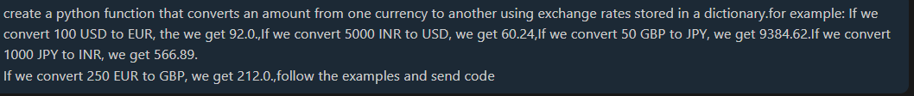

Code:

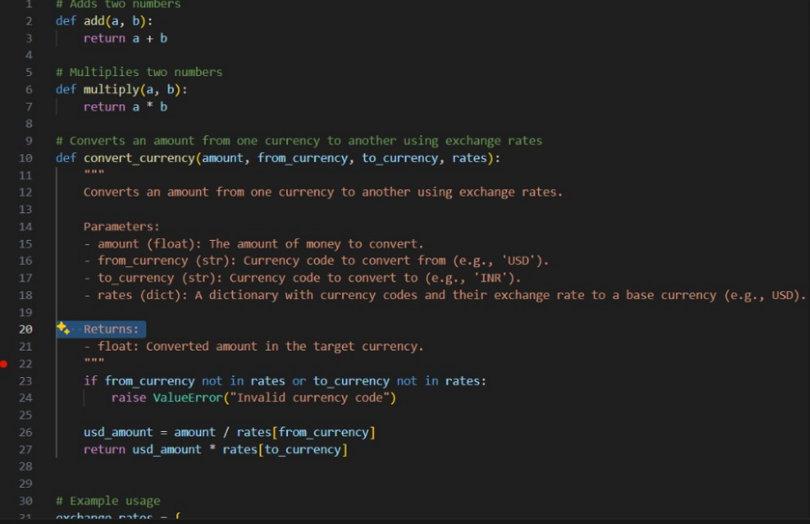

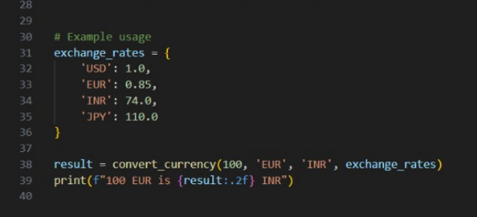

OUTPUT:

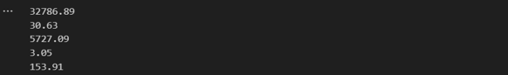

Q2:

2. Write a Python program to extract all email addresses from a block of text using regular expressions. GitHub Copilot along with VS Code. Use zero shot prompting.

Zero-Short Prompting:

Prompt:

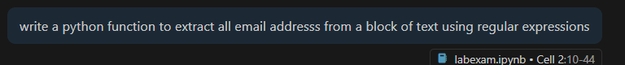

Code:

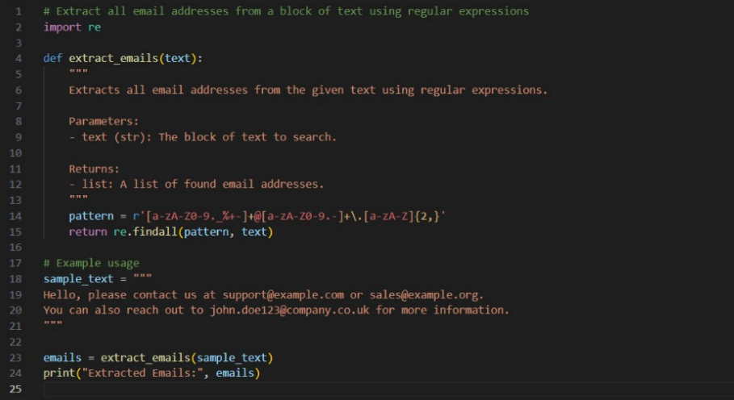

OUTPUT:



Q3:

3. Given a list of movies with their genres, Write a Python function that recommends movies based on a user's preferred genre. Use the Cursor Al tool. Use few shot prompting.

Prompt:

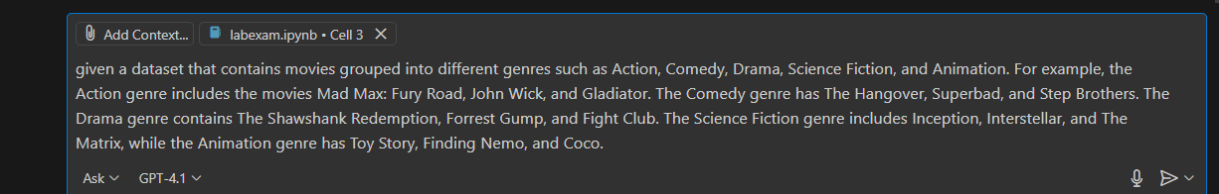



Code:

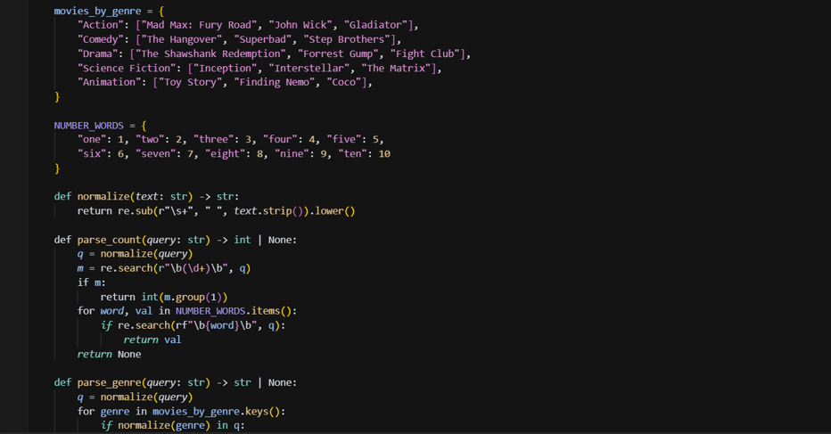

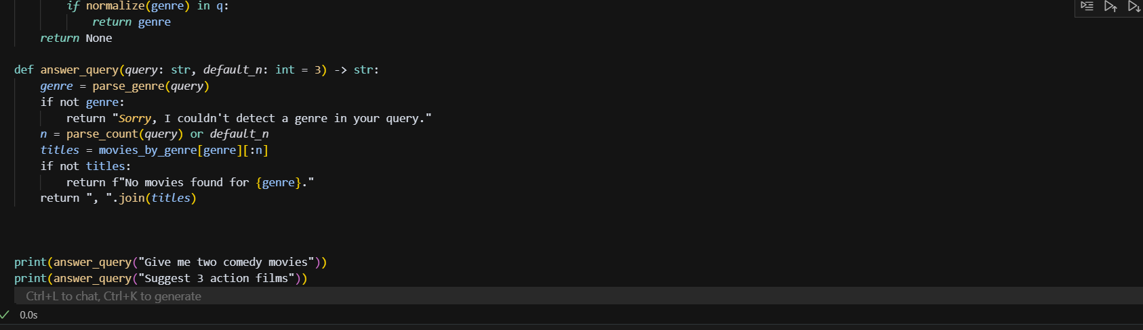

Output:



Q4:

Write Python code that reads a CSV file containing student names and marks in 3 subjects.

Calculate the total and average marks for each student. Use the Cursor AI tool.

Prompt:



Code:

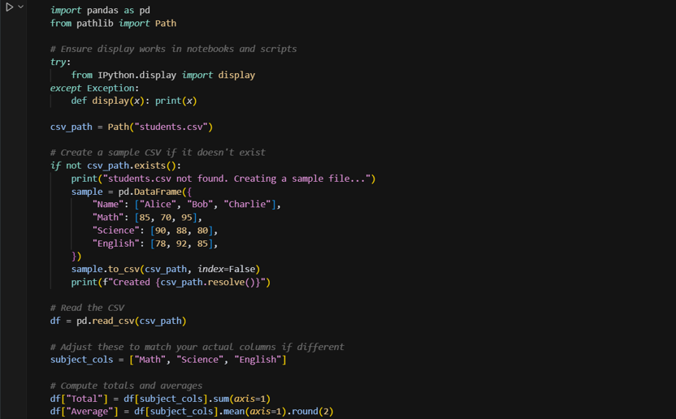

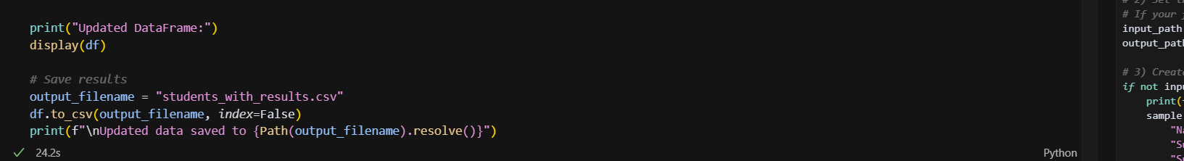

OUTPUT:

